Trail of breadcrumbs to WEEK 52 in SQL

First,

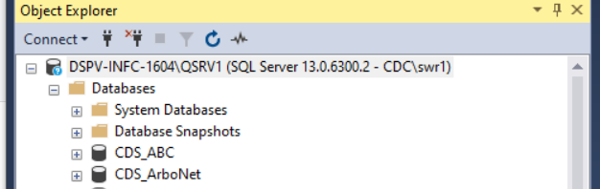

THEN,

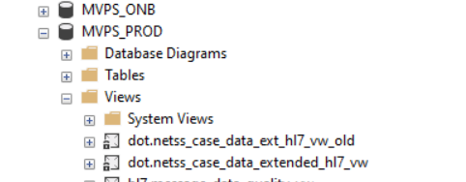

THEN,

